Stratford St Mary, join in this celebration of your AONB
Wednesday 20th May 2020 marks an important anniversary
Join us in celebrating this 50th year of designation
as an Area of Outstanding Natural Beauty
Things look a little different in this wonderful area at the moment, and the plans to celebrate are a little different too, but we really hope that as an important part of this wonderful landscape, you will help us by joining our virtual birthday celebration.
Visit our website www.dedhamvalestourvalley.org.uk
Follow us on social media –
Twitter @DedhamValeSVP
Facebook @dedhamvaleAONB.
The Facebook page is completely new, so if you would follow us on that, we'd be really grateful as we start to build a following there.
Remember, our 50th Birthday is on
Wednesday 20th May
the actual date 50 years ago that the area was designated.

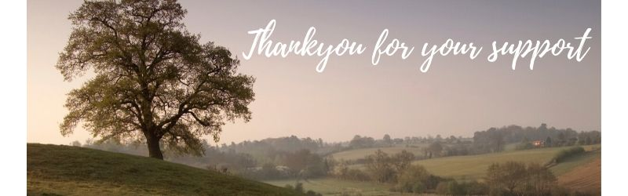
CATCH UP WITH OUR SPRING/ SUMMER NEWSAPER
Caught up on our Spring/Summer newspaper yet? >
find us online: www.dedhamvalestourvalley.org.uk
email us: dedhamvale.project@suffolk.gov.uk

