New awards launched to celebrate and recognise outstanding contributions to National Landscapes in Suffolk and Essex
Brand new awards have been launched in 2021 to celebrate and recognise the achievements of individuals, groups and organisations that have made an outstanding contribution to conserving and enhancing the Coast & Heaths and Dedham Vale Areas of Outstanding Natural Beauty (AONB) and Stour Valley.
The Awards will recognise the hard work and amazing contributions that people are making to improve the AONBs, helping to make them an even better place for wildlife, communities, and visitors alike.
The awards are named after David Wood; Chairman of the Coast and Heaths AONB Joint Advisory Committee and Partnership, and Robert Erith TD DL; the former Chairman of the Dedham Vale AONB and Stour Valley Partnership. Both are lifelong advocates for these special landscapes and the awards aim to inspire others to get involved in the AONB to ensure the outstanding landscape, wildlife, heritage and culture is protected for all to enjoy for many generations to come.
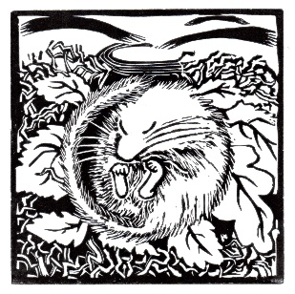
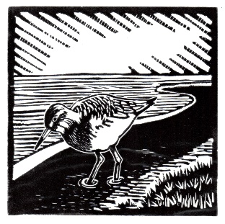
With the first awards to be presented in 2021, they will become an annual award scheme. Award winners will receive a framed copy of a linocut print created by local artist, Jem Seeley, and produced by Drab Ltd featuring the AONB’s iconic species – hazel dormouse in the Dedham Vale AONB and Stour Valley, and Redshank in the Coast and Heaths AONB.
Anyone can be nominated for the award if they have made an outstanding contribution to the AONB in the following areas:
- Landscape and farming | - Biodiversity | - Tourism
- Outdoor education | - Community engagement
- Access to the countryside | - Culture | - Heritage

Visit our websites to make a nomination. The closing date is 7th February 2021.
suffolkcoastandheaths.org/awards/ or dedhamvalestourvalley.org/awards/
For more information on the awards, you can contact AONB Countryside Projects Officer Emma Black by email or by phone on 01394 445225.

